**WEB TECHNOLOGY LAB**

**ETCS-356**

Faculty name: Mr AnupamStudent name: Rohit Kumar

Roll No.: 08814802715

Semester: 6



Maharaja Agrasen Institute of Technology, PSP area, Sector – 22, Rohini,

New Delhi – 110085

( Affiliated to Guru Gobind Singh Indraprastha University, New Delhi )

**Index**

|  |  |  |  |  |  |
| --- | --- | --- | --- | --- | --- |
| **Exp. no.** | **Experiment Name** | **Date of Performance** | **Date of Checking** | **Marks** | **Signature** |
| 1. | Introduction and Installation of xampp. | 19/1/2018 |  |  |  |
| 2. | Static home page using HTML. | 19/1/2018 |  |  |  |
| 3. | Adding header,footer,CSS home page. | 2/2/2018 |  |  |  |
| 4. | Create a HTML form. | 9/3/2018 |  |  |  |
| 5. | Store data of HTML form in MYSQL using JSP. | 9/3/2018 |  |  |  |
| 6. | Adding form validations using JS. | 16/3/2018 |  |  |  |
| 7. | Calculations using JS . | 16/3/2018 |  |  |  |
| 8. | Style XML using XSLT | 6/4/2018 |  |  |  |



**MAHARAJA AGRASEN INSTITUTE OF TECHNOLOGY**

**VISION**

To nurture young minds in a learning environment of high academic value and imbibe spiritual and ethical values with technological and management competence.

**MISSION**

The Institute shall endeavor to incorporate the following basic missions in the teaching methodology:

**Engineering Hardware – Software Symbiosis**

Practical exercises in all Engineering and Management disciplines shall be carried out by Hardware equipment as well as the related software enabling deeper understanding of basic concepts and encouraging inquisitive nature.

**Life – Long Learning**

The Institute strives to match technological advancements and encourage students to keep updating their knowledge for enhancing their skills and inculcating their habit of continuous learning.

**Liberalization and Globalization**

The Institute endeavors to enhance technical and management skills of students so that they are intellectually capable and competent professionals with Industrial Aptitude to face the challenges of globalization.

**Diversification**

The Engineering, Technology and Management disciplines have diverse fields of studies with different attributes. The aim is to create a synergy of the above attributes by encouraging analytical thinking.

**Digitization of Learning Processes**

The Institute provides seamless opportunities for innovative learning in all Engineering and Management disciplines through digitization of learning processes using analysis, synthesis, simulation, graphics, tutorials and related tools to create a platform for multi-disciplinary approach.

**Entrepreneurship**

The Institute strives to develop potential Engineers and Managers by enhancing their skills and research capabilities so that they become successful entrepreneurs and responsible citizens.



**MAHARAJA AGRASEN INSTITUTE OF TECHNOLOGY**

**COMPUTER SCIENCE & ENGINEERING DEPARTMENT**

**VISION**

To Produce ―Critical thinkers of Innovative Technology

**MISSION**

To provide an excellent learning environment across the computer science discipline to inculcate professional behavior, strong ethical values, innovative research capabilities and leadership abilities which enable them to become successful entrepreneurs in this globalized world.

1. To nurture an **excellent learning environment** that helps students to enhance their problem solving skills and to prepare students to be lifelong learners by offering a solid theoretical foundation with applied computing experiences and educating them about their **professional, and ethical responsibilities.**
2. To establish **Industry-Institute Interaction,** making students ready for the industrial environment and be successful in their professional lives.
3. To promote **research activities** in the emerging areas of technology convergence.
4. To build engineers who can look into technical aspects of an engineering solution thereby setting a ground for producing successful **entrepreneur.**

**INTRODUCTION TO THE LAB**

**Lab Objective**

The objective of this lab is to make student familiar with languages and software involved in website development and deployment. To become acquainted with web based programming and some of the important GUI based tools.

**Course Outcomes**

At the end of the course, a student will be able to:

C356.1: Configure a Web Server for effectively deploying a website

C356.2: Design and deploy a live website for real life solutions

C356.3: Understand the flow of information and tier-based web development.

C356.4: Understand how aesthetics of a website can be improved.

C356.5: Work with different tools to implement and deploy websites

C356.6: Understand how content management works using an open source deployment.

**Experiment-1**

**Aim**:- Introduction and installation of XAMPP server.

XAMPP stands for Cross-Platform (X), Apache (A), MySQL (M), PHP (P) and Perl (P). It is a simple, lightweight Apache distribution that makes it extremely easy for developers to create a local web server for testing purposes. Everything you need to set up a web server – server application (Apache), database (MySQL), and scripting language (PHP) – is included in a simple extractable file. XAMPP is also cross-platform, which means it works equally well on Linux, Mac and Windows. Since most actual web server deployments use the same components as XAMPP, it makes transitioning from a local test server to a live server is extremely easy as well. Web development using XAMPP is especially beginner friendly, as this popular PHP and MySQL for beginners course will teach you.

XAMPP has four primary components. These are:

1. **Apache**: Apache is the actual web server application that processes and delivers web content to a computer. Apache is the most popular web server online, powering nearly 54% of all websites.

2. **MySQL**: Every web application, howsoever simple or complicated, requires a database for storing collected data. MySQL, which is open source, is the world’s most popular database management system. It powers everything from hobbyist websites to professional platforms like WordPress. You can learn how to master PHP with this free MySQL database for beginners course.

3. **PHP**: PHP stands for Hypertext Preprocessor. It is a server-side scripting language that powers some of the most popular websites in the world, including WordPress and Facebook. It is open source, relatively easy to learn, and works perfectly with MySQL, making it a popular choice for web developers.

4. **Perl**: Perl is a high-level, dynamic programming language used extensively in network programming, system admin, etc. Although less popular for web development purposes, Perl has a lot of niche applications.

Different versions of XAMPP may have additional components such as phpMyAdmin, OpenSSL, etc. to create full-fledged web servers.

**Installation**:

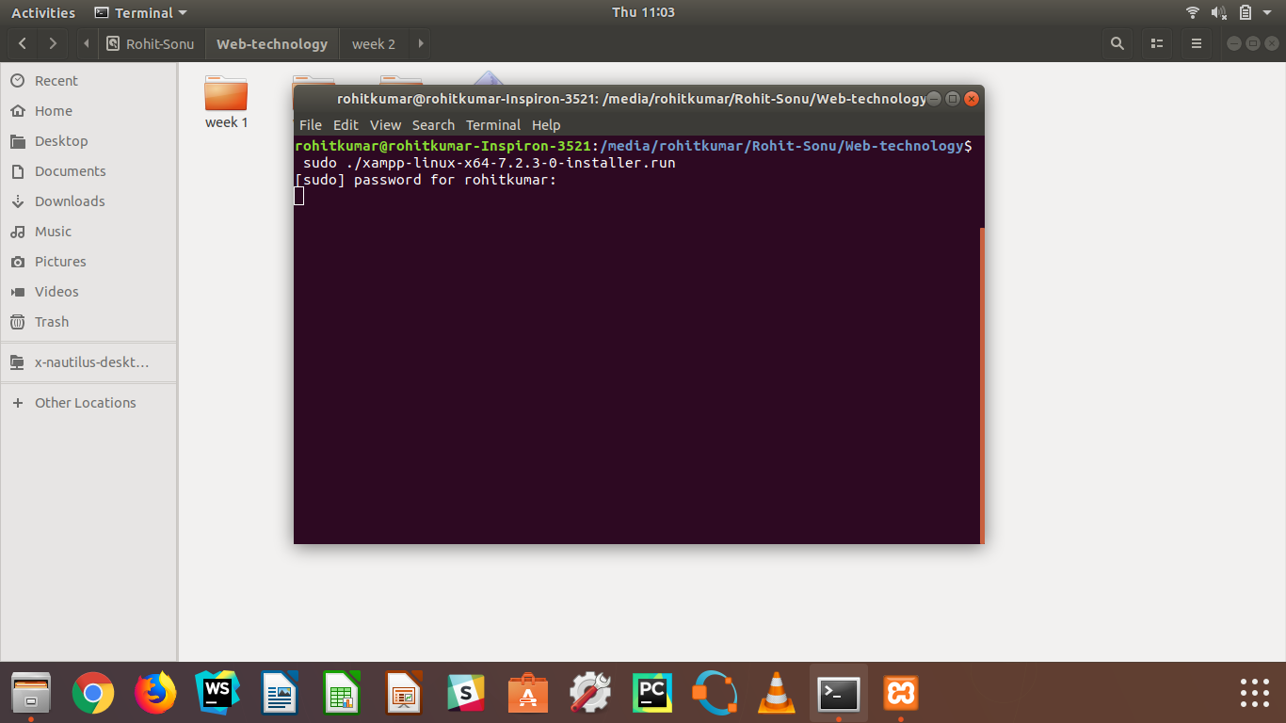

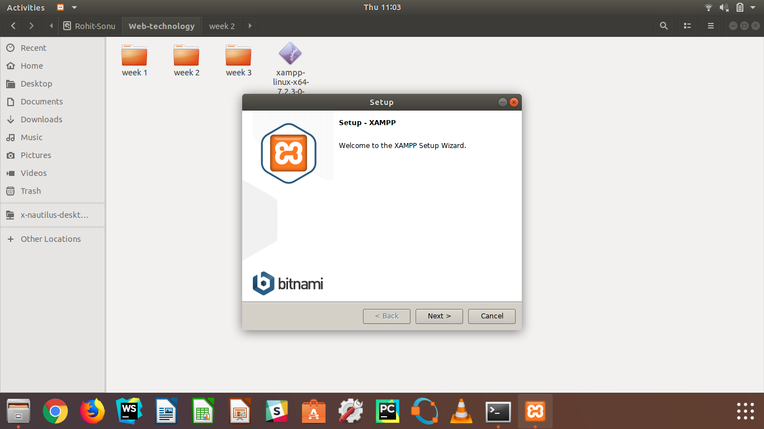

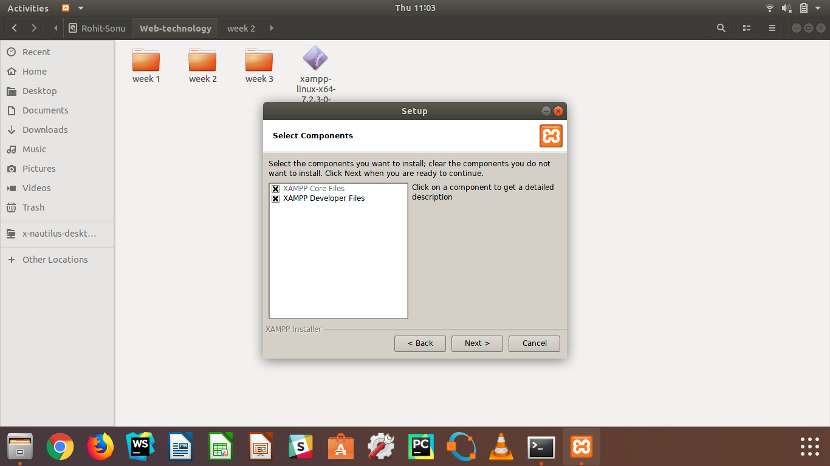

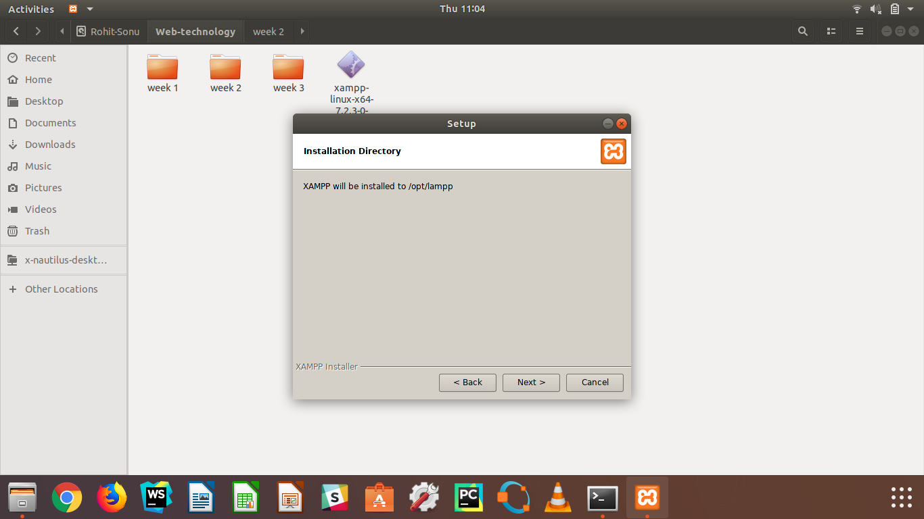

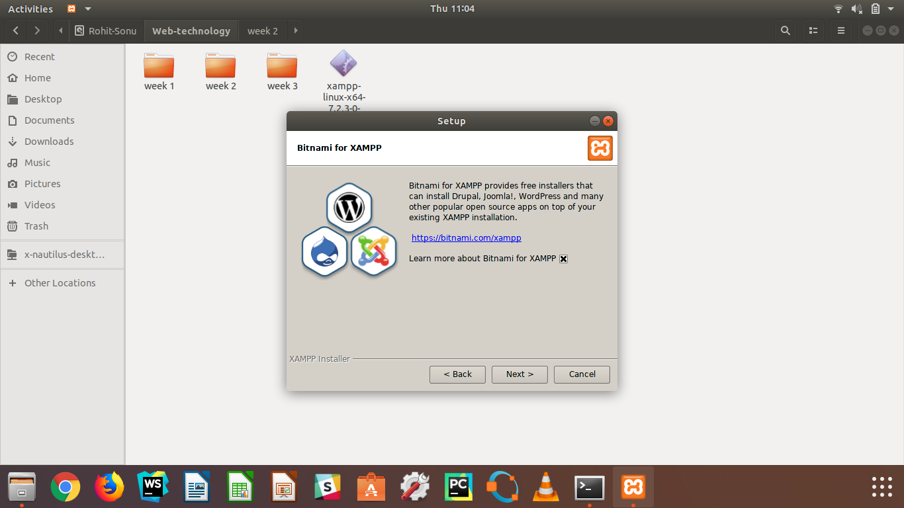

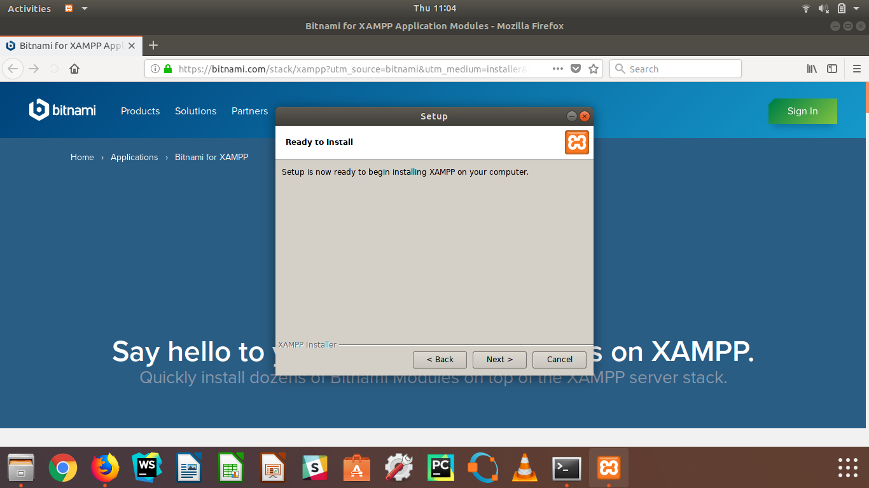

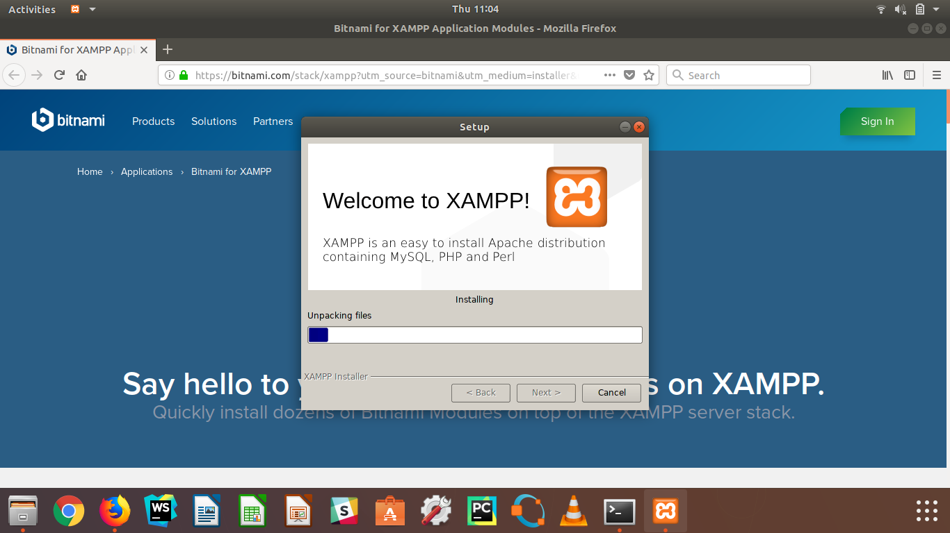

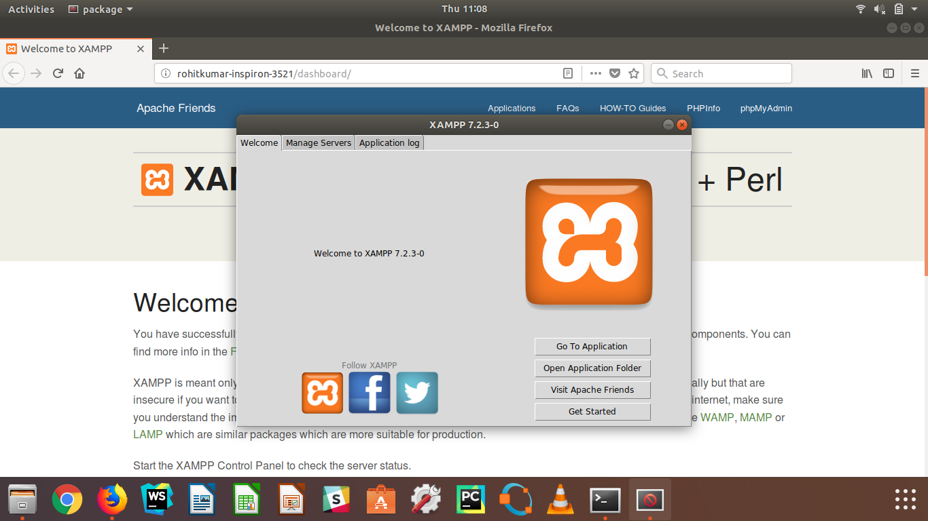

**Experiment-2**

**Aim**:- Introduction to HTML and make a static page home page.

**HTML** was first created by Tim Berners-Lee in 1990. It stands for Hyper Text Markup Language. Hypertext means that the document contains links that allow the reader to jump to other places in the document or to another document altogether. The latest version is known as **HTML5.**

A Markup Language is a way that computers speak to each other to control how text is processed and presented. To do this HTML uses two things: tags and attributes.

* HTML stands for Hyper Text Markup Language
* HTML describes the structure of Web pages using markup
* HTML elements are the building blocks of HTML pages
* HTML elements are represented by tags
* HTML tags label pieces of content such as "heading", "paragraph", "table", and so on
* Browsers do not display the HTML tags, but use them to render the content of the page

**HTML Tags**

HTML tags are element names surrounded by angle brackets:

**<tagname>content goes here...</tagname>**

* HTML tags normally come in pairs like <p> and </p>
* The first tag in a pair is the start tag, the second tag is the end tag
* The end tag is written like the start tag, but with a forward slash inserted before the tag name

**The <!DOCTYPE> Declaration**

The declaration represents the document type, and helps browsers to display web pages correctly. It must only appear once, at the top of the page (before any HTML tags). The declaration is not case sensitive. The declaration for HTML5 is:

<!DOCTYPE html>

**Source code:**

<!DOCTYPE html>

<html lang="en">

<head>

<meta charset="UTF-8">

<title>Food Pandas</title>

<link rel="stylesheet" href="style.css">

</head>

<body>

<header>

<h1>Food Panda</h1>

</header>

<nav>

<span>

<a href="#">

Login

</a>

</span>

<span>

<a href="#">

Signup

</a>

</span>

</nav>

<main>

<div>

<p>

Order Food Onine

</p>

<form action="/" method="post">

<input type="text" placeholder="City" name="city">

<input type="text" placeholder="Enter area" name="area">

<input type="submit" value="Show Restaurants">

</form>

</div>

<div>

<img src="https://asia-public.foodpanda.com/marketing/production/in/images/nl/website-small-banner/paytm_freedelivery_march.jpg" alt="">

<img src="https://asia-public.foodpanda.com/marketing/production/in/images/nl/website-small-banner/300x320-wallet-3.jpg" alt="">

<img src="https://asia-public.foodpanda.com/marketing/production/in/images/nl/2017/ravinder/november/st_images/img_03.png" alt="">

</div>

</main>

<footer>

<div class="grid-container">

<div class="grid-item">

<ul style="list-style: none">

<li>

<b>Popular cities</b>

</li>

<li>

Pune

</li>

<li>

Delhi

</li>

<li>

Pune

</li>

<li>

Delhi

</li>

<li>

Pune

</li>

</ul>

</div>

<div class="grid-item">

<ul style="list-style: none">

<li>

<b>Popular cities</b>

</li>

<li>

Pune

</li>

<li>

Delhi

</li>

<li>

Pune

</li>

<li>

Delhi

</li>

<li>

Pune

</li>

</ul>

</div>

<div class="grid-item">

<ul style="list-style: none">

<li>

<b>Popular cities</b>

</li>

<li>

Pune

</li>

<li>

Delhi

</li>

<li>

Pune

</li>

<li>

Delhi

</li>

<li>

Pune

</li>

</ul>

</div>

</div>

<ul style="display: inline-flex; list-style: none">

<li><a href="#">Term and Conditions</a> &nbsp;&nbsp;&nbsp;</li>

<li><a href="#"> Privacy Policy </a> &nbsp;&nbsp;&nbsp;</li>

<li><a href="#"> &copy; Copyright 2016 foodpanda is a registered trademark </a> &nbsp;&nbsp;&nbsp;</li>

<li><a href="#"> Foodpanda India </a> &nbsp;&nbsp;&nbsp;</li>

</ul>

</footer>

</body>

</html>

**Output:**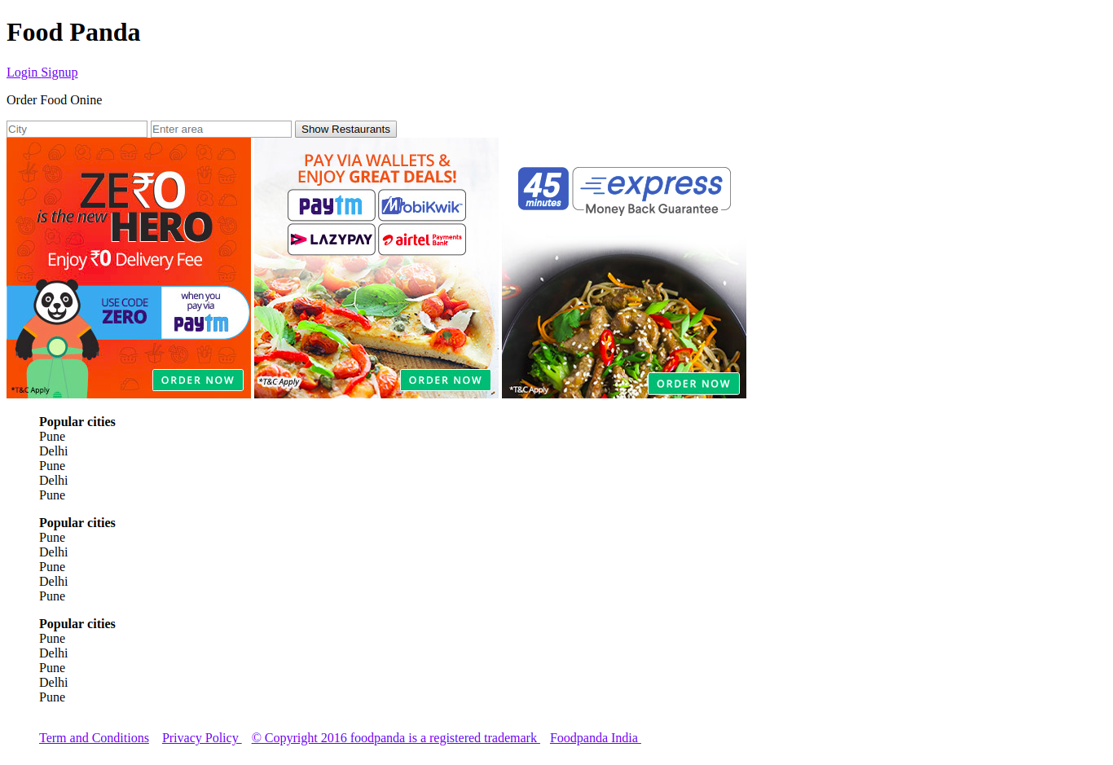

**Experiment-3**

**Aim**:- Introduction to CSS and add header, footer and css to existing homepage.

**Cascading Style Sheets**, fondly referred to as CSS, is a simple design language intended to simplify the process of making web pages presentable.

CSS handles the look and feel part of a web page. Using CSS, you can control the color of the text, the style of fonts, the spacing between paragraphs, how columns are sized and laid out, what background images or colors are used, layout designs,variations in display for different devices and screen sizes as well as a variety of other effects.

CSS is easy to learn and understand but it provides powerful control over the presentation of an HTML document. Most commonly, CSS is combined with the markup languages HTML or XHTML.

**Advantages of CSS**

CSS saves time − You can write CSS once and then reuse same sheet in multiple HTML pages. You can define a style for each HTML element and apply it to as many Web pages as you want.

Pages load faster − If you are using CSS, you do not need to write HTML tag attributes every time. Just write one CSS rule of a tag and apply it to all the occurrences of that tag. So less code means faster download times.

Easy maintenance − To make a global change, simply change the style, and all elements in all the web pages will be updated automatically.

Superior styles to HTML − CSS has a much wider array of attributes than HTML, so you can give a far better look to your HTML page in comparison to HTML attributes.

Multiple Device Compatibility − Style sheets allow content to be optimized for more than one type of device. By using the same HTML document, different versions of a website can be presented for handheld devices such as PDAs and cell phones or for printing.

Global web standards − Now HTML attributes are being deprecated and it is being recommended to use CSS. So its a good idea to start using CSS in all the HTML pages to make them compatible to future browsers.

Offline Browsing − CSS can store web applications locally with the help of an offline catche.Using of this, we can view offline websites.The cache also ensures faster loading and better overall performance of the website.

Platform Independence − The Script offer consistent platform independence and can support latest browsers as well.

**Source code:**

body{

margin: 0;

}

.headerStyle{

display: block;

background-color: darkorange;

}

.headerStyle > h1{

margin: 10px 0 10px 10px;

width: 60%;

display: inline;

}

.headerStyle > nav{

margin: 15px 50px 10px 10px;

font-size: 17px;

float: right;

}

.headerStyle > nav span {

margin: 0 0 0 25px;

}

.headerStyle nav span a{

text-decoration: none;

color: #fff;

}

.headerStyle nav span a:hover{

text-shadow: black 0 1px 1px;

}

.tagline{

margin: 0;

padding-top: 200px;

text-align: center;

background: #ffffff url("https://i.ytimg.com/vi/mEBFswpYms4/maxresdefault.jpg") no-repeat;

background-attachment: fixed;

background-size: cover;

height: 400px;

}

.tagline p {

margin-top: 0;

text-align: center;

color: #fff;

text-shadow: #000 0 1px 1px;

font-size: 50px;

font-family: arial;

}

.tagline-form input[type=text]{

width: 20%;

padding: 5px 20px;

margin: 8px 0;

display: inline-block;

border: 1px solid #ccc;

border-radius: 4px;

box-sizing: border-box;

font-size: 18px;

}

.tagline-form input[type=submit]{

width: 15%;

background-color: #4CAF50;

color: white;

padding: 5px 20px;

margin: 8px 0;

border: none;

border-radius: 4px;

cursor: pointer;

font-size: 18px;

}

.tagline-form input[type=submit]:hover {

background-color: #45a049;

}

.banners{

text-align: center;

padding: 0;

height: 320px;

}

.banners img{

margin: 0 10px;

}

.footer{

text-align: center;

background: #252525;

color: #f5f5f5;

}

.footer a{

text-decoration: none;

color: #f5f5f5;

}

.grid-container {

display: inline-grid;

grid-template-columns: auto auto auto;

width: 100%;

}

.grid-item {

text-align: center;

width: 100%;

}

.grid-item li{

text-align: left;

padding-left: 174px;

}

.loginForm{

background: #ffffff url("https://i.ytimg.com/vi/mEBFswpYms4/maxresdefault.jpg") no-repeat;

background-attachment: fixed;

background-size: cover;

}

.loginForm label{

/*margin: 0 0 12px;*/

display: block;

font-size: 1.25em;

color: #217093;

font-weight: 700;

font-family: inherit;

margin: 0;

}

.loginInput{

width: 67%;

padding: 5px 10px;

margin: 0 0 8px 0;

display: inline-block;

border: 1px solid #ccc;

border-radius: 4px;

box-sizing: border-box;

font-size: 18px;

}

.loginButton{

width: 35%;

background-color: #217093;

color: white;

padding: 5px 20px;

margin: 8px 0;

border: none;

border-radius: 4px;

cursor: pointer;

font-size: 18px;

}

.loginButton:hover{

background-color: #217060;

}

.card{

margin: 20px auto;

width: 30%;

border: 1px solid gray;

padding: 30px;

box-shadow: black 0 1px 1px;

border-radius: 5px;

background-color: black;

opacity: 0.5;

}

.card input{

background: #f5f5f5;

background-blend-mode: lighten;

}

**Output:**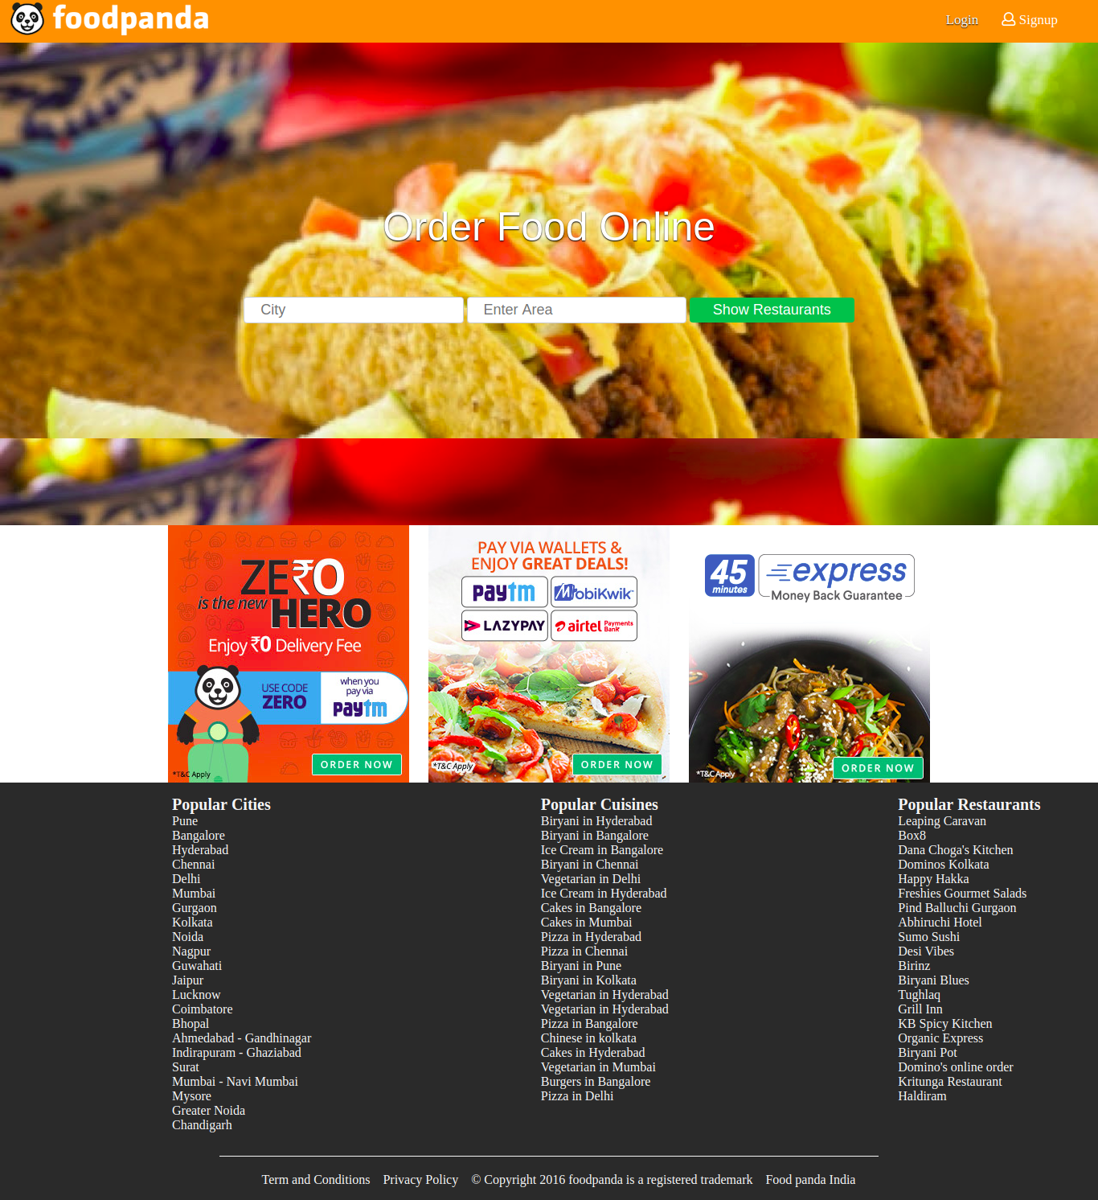

**Experiment-4**

**Aim**:- Add table and form to web page.

**Defining an HTML Table**

An HTML table is defined with the <table> tag.

Each table row is defined with the <tr> tag. A table header is defined with the <th> tag. By default, table headings are bold and centered. A table data/cell is defined with the <td> tag.

**HTML Table - Adding a Border**

If you do not specify a border for the table, it will be displayed without borders.

**table, th, td {**

**border: 1px solid black;**

**}**

A border is set using the CSS border property:

**HTML Table - Collapsed Borders**

If you want the borders to collapse into one border, add the CSS border-collapse property:

**table, th, td {**

**border: 1px solid black;**

**border-collapse: collapse;**

**}**

**Defining an HTML Form**

The HTML <form> element defines a form that is used to collect user input:

**<form>**

**form elements**

**</form>**

An HTML form contains form elements.

Form elements are different types of input elements, like text fields, checkboxes, radio buttons, submit buttons, and more.

**The <input> Element**

The <input> element is the most important form element.

The <input> element can be displayed in several ways, depending on the type attribute.

**Source code:**

<main>

<div class="grid-container " style="grid-template-columns: auto">

<form class="grid-item loginForm">

<div class="card">

<div class="inputGroup inputGroup1">

<label for="firstname" style="padding-right: 178px;">First Name</label>

<input class = "loginInput" type="text" id="firstname" maxlength="256" required/>

</div>

<div class="inputGroup inputGroup1">

<label for="lastname" style="padding-right: 178px;">Last Name</label>

<input class = "loginInput" type="text" id="lastname" maxlength="256" required/>

</div>

<div class="inputGroup inputGroup1">

<label for="mobile" style="padding-right: 178px;">Mobile No.</label>

<input class = "loginInput" type="text" id="mobile" maxlength="256" required/>

</div>

<div class="inputGroup inputGroup1">

<label for="email" style="padding-right: 220px;">Email</label>

<input class = "loginInput" type="text" id="email" maxlength="256" required/>

</div>

<div class="inputGroup inputGroup2">

<label for="password" style="padding-right: 185px;">Password</label>

<input type="password" id="password" class = "loginInput" required/>

</div>

<div class="inputGroup inputGroup2">

<label for="password" style="padding-right: 113px;">Confirm Password</label>

<input type="password" id="repassword" class = "loginInput" required/>

</div>

<div class="inputGroup inputGroup3">

<input type="submit" id="formSubmit" class="loginButton"/>

</div>

</div>

</form>

</div>

</main>

**Output:**

Login Page

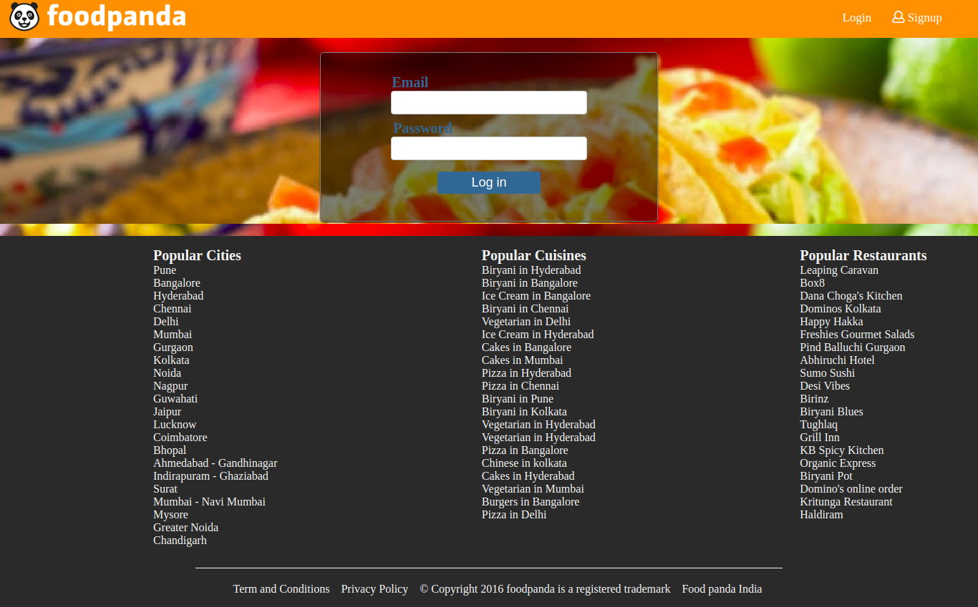

Signup page

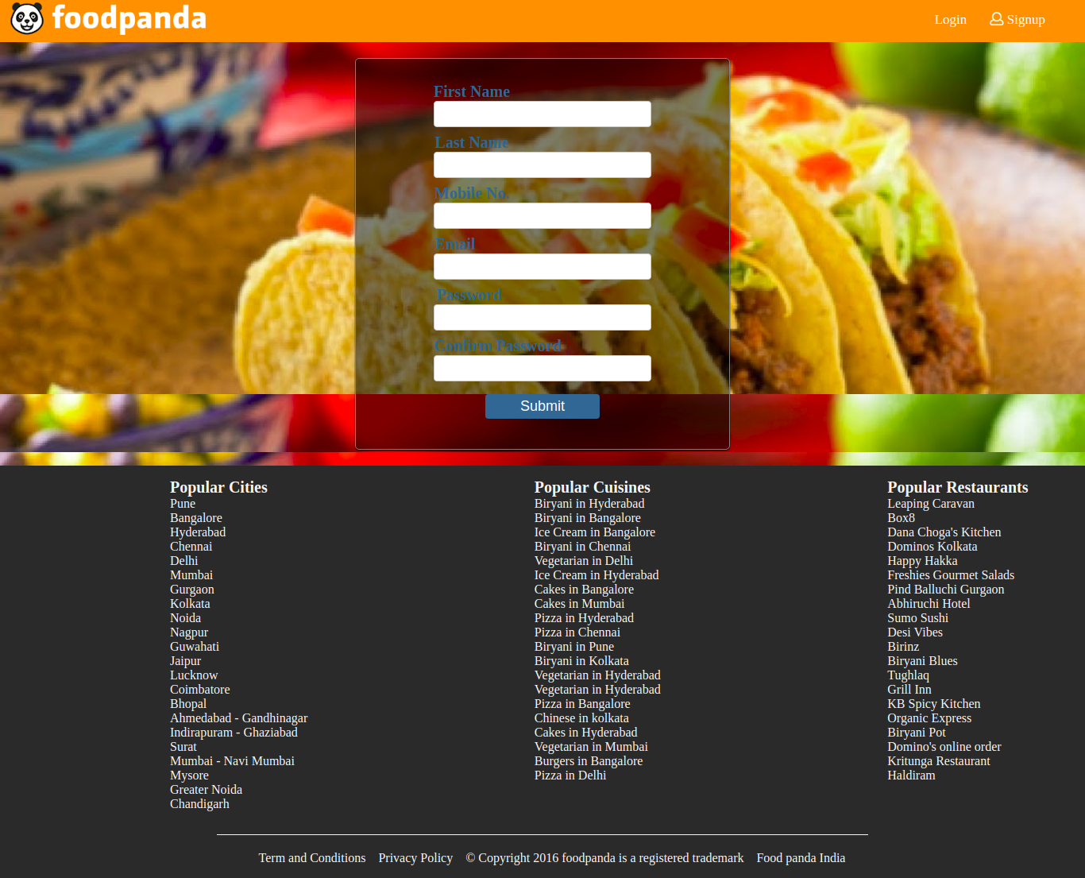

**Experiment-5**

**Aim**:- To submit form using JSP and MySQL.

**JavaServer Pages** (JSP) is a technology for developing Webpages that supports dynamic content. This helps developers insert java code in HTML pages by making use of special JSP tags, most of which start with <% and end with %>.

A JavaServer Pages component is a type of Java servlet that is designed to fulfill the role of a user interface for a Java web application. Web developers write JSPs as text files that combine HTML or XHTML code, XML elements, and embedded JSP actions and commands.

JSP tags can be used for a variety of purposes, such as retrieving information from a database or registering user preferences, accessing JavaBeans components, passing control between pages, and sharing information between requests, pages etc.

**MySQL** is a fast, easy-to-use RDBMS being used for many small and big businesses. MySQL is developed, marketed and supported by MySQL AB, which is a Swedish company. MySQL is becoming so popular because of many good reasons −

* MySQL is released under an open-source license. So you have nothing to pay to use it.
* MySQL is a very powerful program in its own right. It handles a large subset of the functionality of the most expensive and powerful database packages.
* MySQL uses a standard form of the well-known SQL data language.
* MySQL works on many operating systems and with many languages including PHP, PERL, C, C++, JAVA, etc.

**Source code:**

**JSP**

<%@ page import="java.sql.*" %>

<%

String connectionURL = "jdbc:mysql://sql.school.edu:3306/user";

Connection connection = null;

Statement statement = null;

ResultSet rs = null;

Class.forName("com.mysql.jdbc.Driver").newInstance();

connection = DriverManager.getConnection(connectionURL, "user", "password");

statement = connection.createStatement();

String firstname=request.getParameter("firstname");

String lastname=request.getParameter("lastname");

String mobile=request.getParameter("mobile");

String password=request.getParameter("password");

String email=request.getParameter("email");

try

{

Class.forName("com.mysql.jdbc.Driver");

Connection conn = DriverManager.getConnection("jdbc:mysql://localhost:3306/test", "root", "");

Statement st=conn.createStatement();

int i=st.executeUpdate("insert into users(firstname,lastname,mobile,email,password)values('"+firstname+"','"+lastname+"','"+mobile+"','"+email+"','"+password+"')");

out.println("Data is successfully inserted!");

}

catch(Exception e)

{

System.out.print(e);

e.printStackTrace();

}

%>

**Output:**

**Signup page**

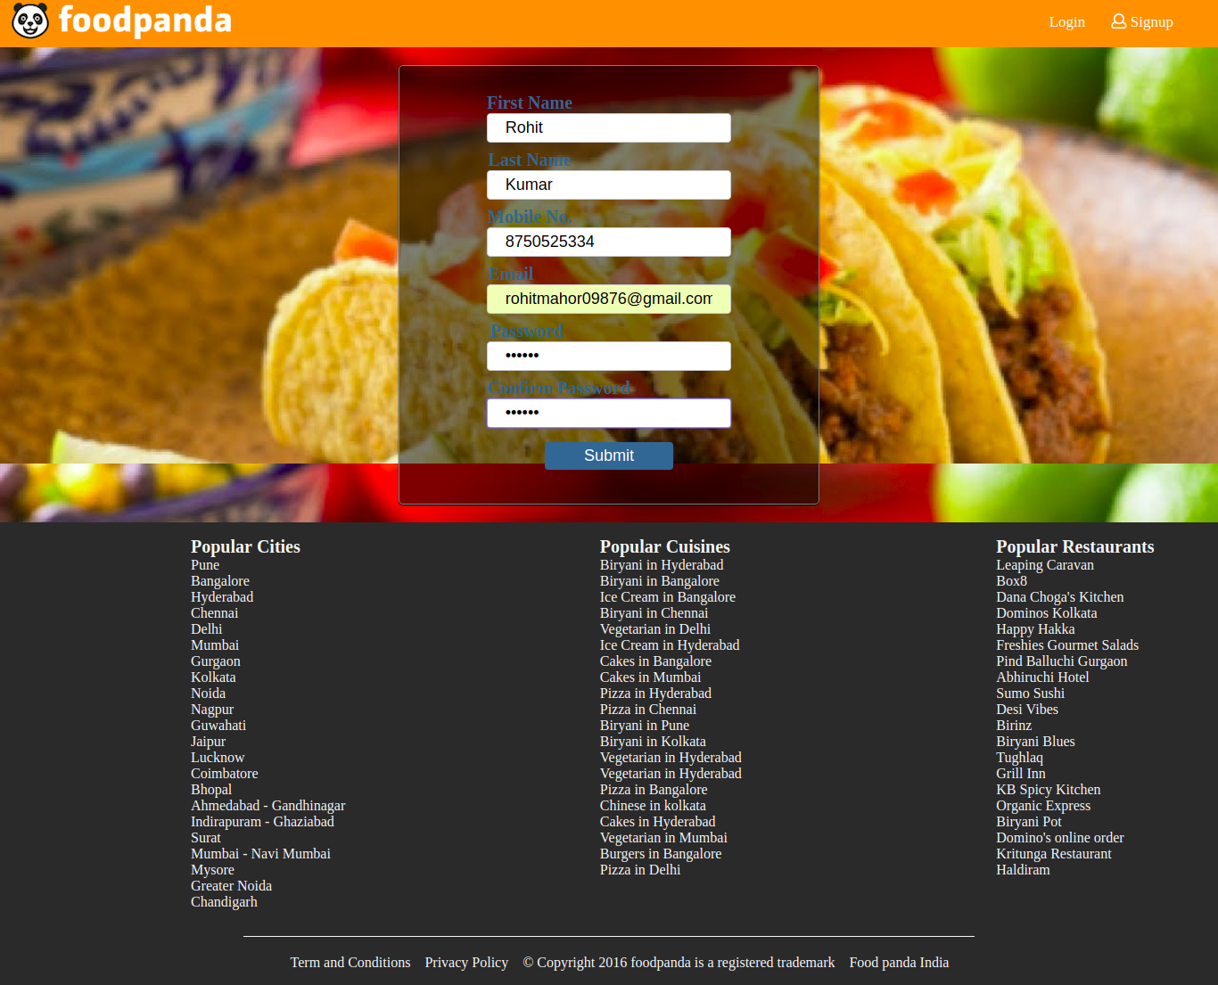

**SQL Table:**

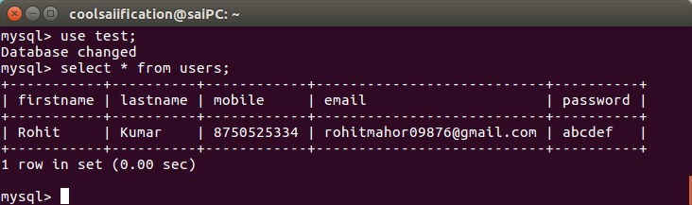

**Experiment-6**

**Aim**:- Form validation using javaScript.

Javascript is a dynamic computer programming language. It is lightweight and most commonly used as a part of web pages, whose implementations allow client-side script to interact with the user and make dynamic pages. It is an interpreted programming language with object-oriented capabilities.

JavaScript was first known as LiveScript, but Netscape changed its name to JavaScript, possibly because of the excitement being generated by Java. JavaScript made its first appearance in Netscape 2.0 in 1995 with the name LiveScript. The general-purpose core of the language has been embedded in Netscape, Internet Explorer, and other web browsers.

The ECMA-262 Specification defined a standard version of the core JavaScript language.

* JavaScript is a lightweight, interpreted programming language.
* Designed for creating network-centric applications.
* Complementary to and integrated with Java.
* Complementary to and integrated with HTML.
* Open and cross-platform

Advantages of JavaScript

The merits of using JavaScript are −

**Less server interaction** − You can validate user input before sending the page off to the server. This saves server traffic, which means less load on your server.

**Immediate feedback to the visitors** − They don't have to wait for a page reload to see if they have forgotten to enter something.

**Increased interactivity** − You can create interfaces that react when the user hovers over them with a mouse or activates them via the keyboard.

**Source code:**

function formValidation(){

mobile = document.getElementById('mobile');

email = document.getElementById('email');

pass = document.getElementById('password');

confpass = document.getElementById('repassword');

if(phonenumber(mobile)){

if(ValidateEmail(email)){

if(validatePass(pass, confpass)){

alert('Successfully signup');

}

}

}

}

function phonenumber(inputtxt)

{

var phoneno = /^\d{10}$/;

if(inputtxt.value.match(phoneno))

{

return true;

}

else

{

// phoneo.focus();

alert("Invalid mobile number");

return false;

}

}

function ValidateEmail(uemail)

{

var mailformat = /^\w+([\.-]?\w+)*@\w+([\.-]?\w+)*(\.\w{2,3})+$/;

if(uemail.value.match(mailformat))

{

return true;

}

else

{

alert("You have entered an invalid email address!");

// uemail.focus();

return false;

}

}

function validatePass(pass, confpass){

if(pass.value == confpass.value){

// confpass.focus();

return true;

}

else{

alert(“Password and Confirm password should be same”);

return false;

}

}

**Output:**

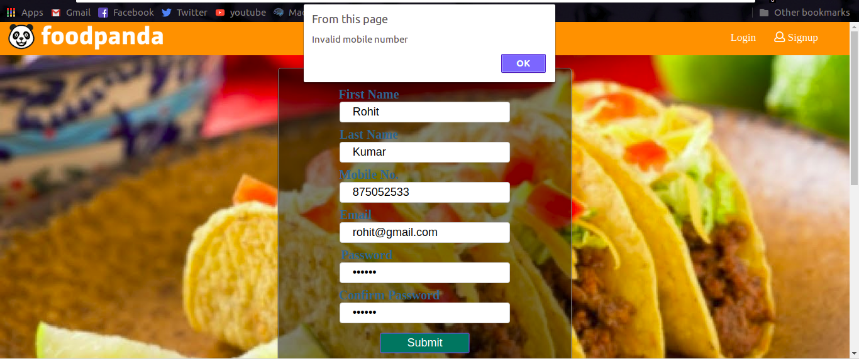

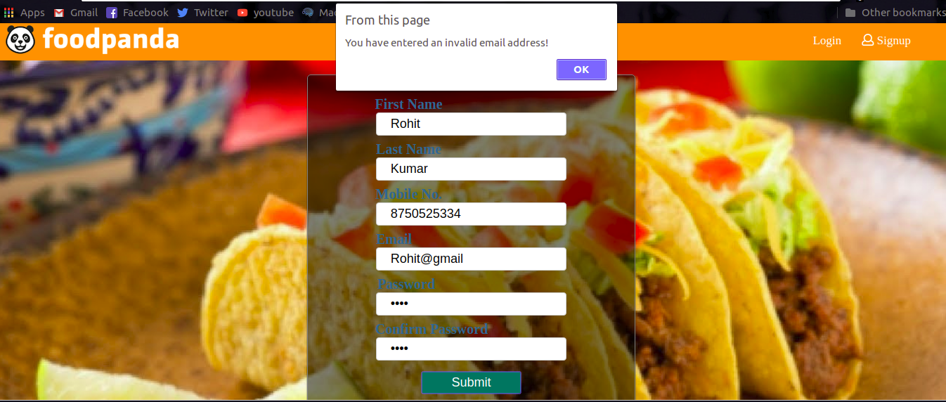

**Experiment 7**

**Aim:** To add javascript calculation to the website.

**Source Code:**

**HTML**

<!DOCTYPE html>

<html lang="en">

<head>

<meta charset="UTF-8">

<title>Food Pandas</title>

<link rel="stylesheet" href="style.css">

<link rel="stylesheet" href="https://use.fontawesome.com/releases/v5.0.9/css/all.css" integrity="sha384-5SOiIsAziJl6AWe0HWRKTXlfcSHKmYV4RBF18PPJ173Kzn7jzMyFuTtk8JA7QQG1" crossorigin="anonymous">

<style>

table {

font-family: arial, sans-serif;

border-collapse: collapse;

width: 100%;

}

td, th {

/*border: 1px solid #dddddd;*/

text-align: left;

padding: 8px;

}

tr:nth-child(even) {

background-color: #dddddd;

}

#menu{

border-radius: 5px;

margin: auto auto;

width: 50%;

height: 243px;

padding: 50px;

background: #f5f5f5;

}

#total{

border: 1px solid black;

background: rgba(228, 0, 0, 0.6);

margin: 50px auto;

width: 25%;

height: 50px;

font-size: 35px;

padding-top: 10px;

color: white;

border-radius: 10px;

}

</style>

</head>

<body>

<header class="headerStyle">

<h1>

<img src="logo.png" alt="logo">

</h1>

<nav>

<span>

<a href="signup.html">

<i class="far fa-user"></i>

Logout

</a>

</span>

</nav>

</header>

<main>

<div class="tagline" style="height: 500px">

<div id="menu">

<img src="https://assets-in.foodpanda.in/dynamic/production/in/images/menucategories/2107384_menu.jpg" alt="SoupImage">

<table>

<tr>

<td>Cream of Tomato Soup</td>

<td>

Rs.80.00

<button id="soup1" value="80">ADD</button>

</td>

</tr>

<tr>

<td>Cream of Tomato Soup</td>

<td>

Rs.90.00

<button id="soup2" value="90">ADD</button>

</td>

</tr>

<tr>

<td>Veg. Sweet Corn Soup</td>

<td>

Rs.105.00

<button id="soup3" value="105">ADD</button>

</td>

</tr>

<tr>

<td>Veg. Hot & Sour Soup</td>

<td>

Rs.110.00

<button id="soup4" value="110">ADD</button>

</td>

</tr>

</table>

</div>

<div id="total">

Total Amount = 0

</div>

</div>

<div class="banners">

<img src="https://asia-public.foodpanda.com/marketing/production/in/images/nl/website-small-banner/paytm_freedelivery_march.jpg" alt="">

<img src="https://asia-public.foodpanda.com/marketing/production/in/images/nl/website-small-banner/300x320-wallet-3.jpg" alt="">

<img src="https://asia-public.foodpanda.com/marketing/production/in/images/nl/2017/ravinder/november/st_images/img_03.png" alt="">

</div>

</main>

<footer class="footer">

<div class="grid-container">

<div class="grid-item">

<ul style="list-style: none">

<li style="font-size: 20px">

<b>Popular Cities</b>

</li>

<li>Pune</li>

<li>Bangalore</li>

<li>Hyderabad</li>

<li>Chennai</li>

<li>Delhi</li>

<li>Mumbai</li>

<li>Gurgaon</li>

<li>Kolkata</li>

<li>Noida</li>

<li>Nagpur</li>

<li>Guwahati</li>

<li>Jaipur</li>

<li>Lucknow</li>

<li>Coimbatore</li>

<li>Bhopal</li>

<li>Ahmedabad - Gandhinagar</li>

<li>Indirapuram - Ghaziabad</li>

<li>Surat</li>

<li>Mumbai - Navi Mumbai</li>

<li>Mysore</li>

<li>Greater Noida</li>

<li>Chandigarh</li>

</ul>

</div>

<div class="grid-item">

<ul style="list-style: none">

<li style="font-size: 20px">

<b>Popular Cuisines</b>

</li>

<li>

Biryani in Hyderabad

</li>

<li>Biryani in Bangalore</li>

<li>Ice Cream in Bangalore</li>

<li>Biryani in Chennai</li>

<li>Vegetarian in Delhi</li>

<li>Ice Cream in Hyderabad</li>

<li>Cakes in Bangalore</li>

<li>Cakes in Mumbai</li>

<li>Pizza in Hyderabad</li>

<li>Pizza in Chennai</li>

<li>Biryani in Pune</li>

<li>Biryani in Kolkata</li>

<li>Vegetarian in Hyderabad</li>

<li>Vegetarian in Hyderabad</li>

<li>Pizza in Bangalore</li>

<li>Chinese in kolkata</li>

<li>Cakes in Hyderabad</li>

<li>Vegetarian in Mumbai</li>

<li>Burgers in Bangalore</li>

<li>Pizza in Delhi</li>

</ul>

</div>

<div class="grid-item">

<ul style="list-style: none">

<li style="font-size: 20px">

<b>Popular Restaurants</b>

</li>

<li>Leaping Caravan</li>

<li>Box8</li>

<li>Dana Choga's Kitchen</li>

<li>Dominos Kolkata</li>

<li>Happy Hakka</li>

<li>Freshies Gourmet Salads</li>

<li>Pind Balluchi Gurgaon</li>

<li>Abhiruchi Hotel</li>

<li>Sumo Sushi</li>

<li>Desi Vibes</li>

<li>Birinz</li>

<li>Biryani Blues</li>

<li>Tughlaq</li>

<li>Grill Inn</li>

<li>KB Spicy Kitchen</li>

<li>Organic Express</li>

<li>Biryani Pot</li>

<li>Domino's online order</li>

<li>Kritunga Restaurant</li>

<li>Haldiram</li>

</ul>

</div>

</div>

<div class="grid-container" style="width: 60%;height: 0;border-top: 1px solid #f5f5f5"></div>

<ul style="display: inline-flex; list-style: none">

<li><a href="#">Term and Conditions</a> &nbsp;&nbsp;&nbsp;</li>

<li><a href="#"> Privacy Policy </a> &nbsp;&nbsp;&nbsp;</li>

<li><a href="#"> &copy; Copyright 2016 foodpanda is a registered trademark </a> &nbsp;&nbsp;&nbsp;</li>

<li><a href="#"> Food panda India </a> &nbsp;&nbsp;&nbsp;</li>

</ul>

</footer>

<script src="validation.js"></script>

<script src="addValue.js"></script>

</body>

</html>

**Javascript**

btn1 = document.getElementById("soup1");

btn2 = document.getElementById("soup2");

btn3 = document.getElementById("soup3");

btn4 = document.getElementById("soup4");

val = 0;

btn1.addEventListener("click",

function () {

console.log('1');

val = val + parseInt(btn1.value);

document.getElementById("total").innerHTML = "Total Amount = " + val;

}

);

btn2.addEventListener("click",

function () {

console.log('1');

val = val + parseInt(btn2.value);

document.getElementById("total").innerHTML = "Total Amount = " + val;

}

);

btn3.addEventListener("click",

function () {

console.log('1');

val = val + parseInt(btn3.value);

document.getElementById("total").innerHTML = "Total Amount = " + val;

}

);

btn4.addEventListener("click",

function () {

console.log('1');

val = val + parseInt(btn4.value);

document.getElementById("total").innerHTML = "Total Amount = " + val;

}

);

**Output:**

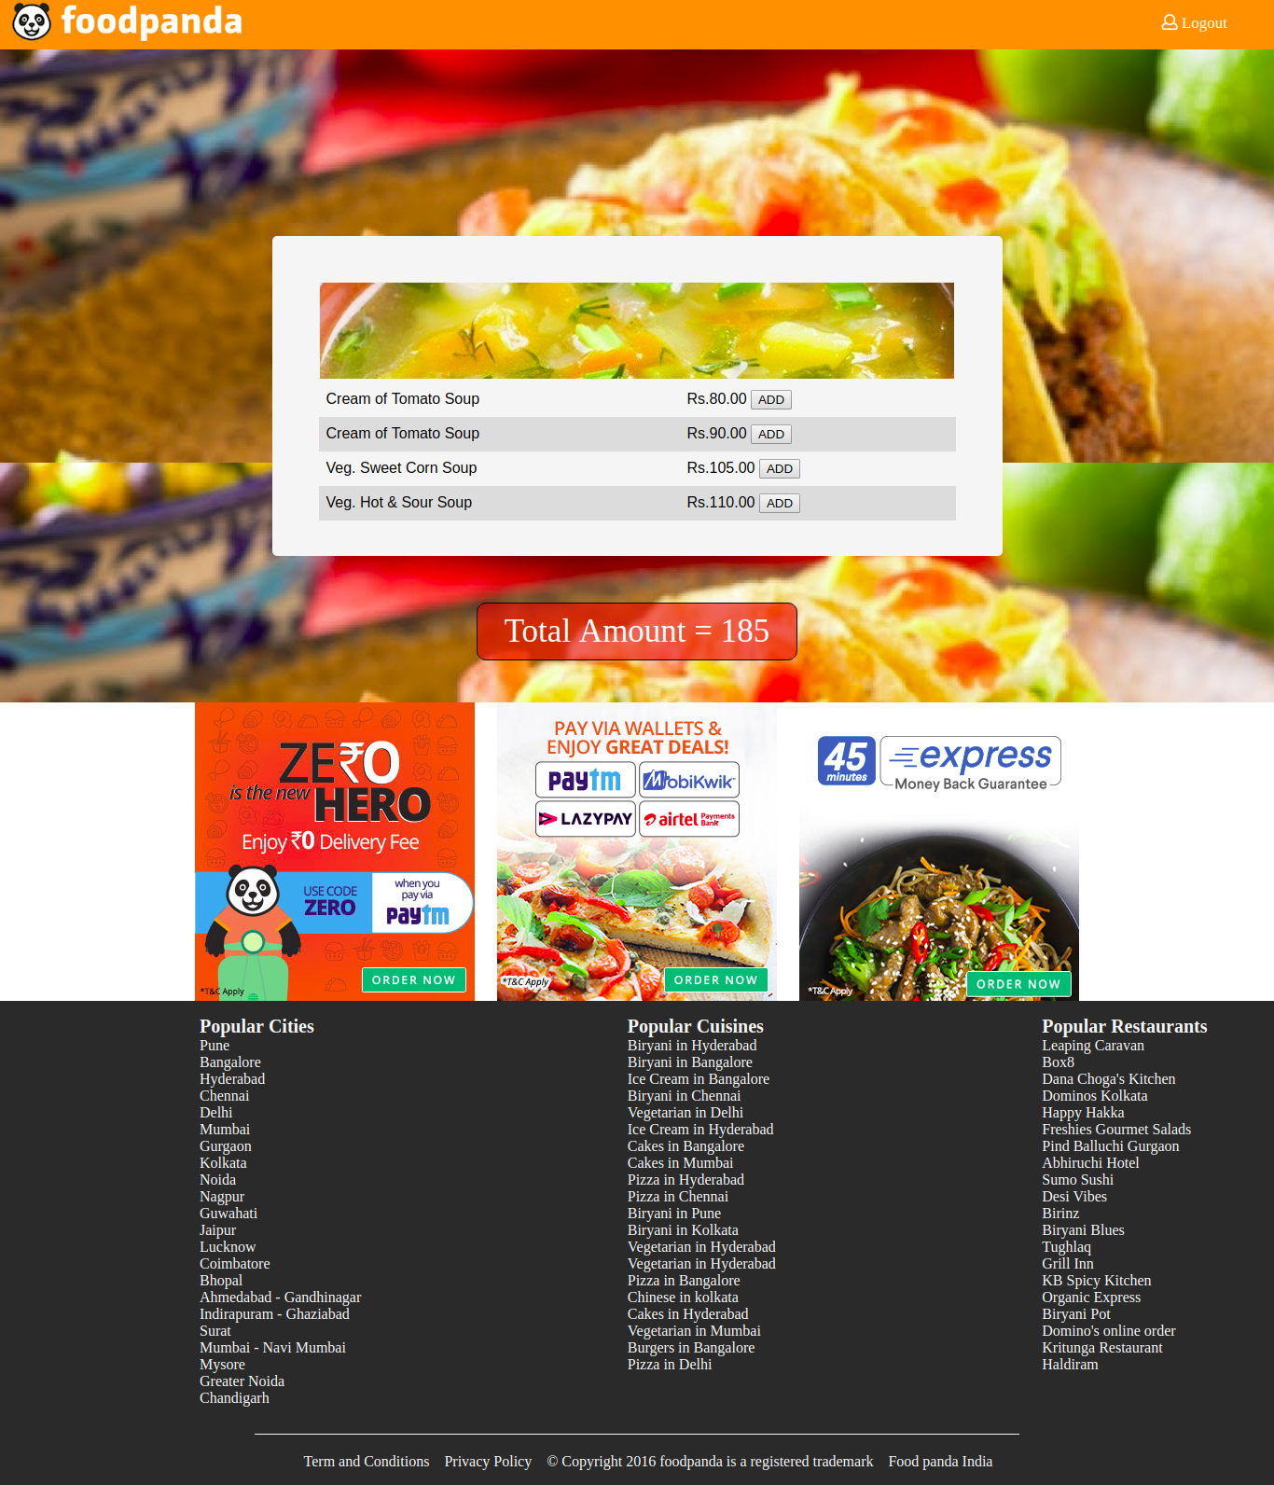

**Experiment 8**

**Aim:** To add XML and add CSS in XSL.

**XML**

XML stands for Extensible Markup Language. It is a text-based markup language derived from Standard Generalized Markup Language (SGML).

XML tags identify the data and are used to store and organize the data, rather than specifying how to display it like HTML tags, which are used to display the data. XML is not going to replace HTML in the near future, but it introduces new possibilities by adopting many successful features of HTML.

There are three important characteristics of XML that make it useful in a variety of systems and solutions −

* XML is extensible − XML allows you to create your own self-descriptive tags, or language, that suits your application.
* XML carries the data, does not present it − XML allows you to store the data irrespective of how it will be presented.
* XML is a public standard − XML was developed by an organization called the World Wide Web Consortium (W3C) and is available as an open standard.

**XML Usage**

A short list of XML usage says it all −

* XML can work behind the scene to simplify the creation of HTML documents for large web sites.
* XML can be used to exchange the information between organizations and systems.
* XML can be used for offloading and reloading of databases.
* XML can be used to store and arrange the data, which can customize your data handling needs.
* XML can easily be merged with style sheets to create almost any desired output.
* Virtually, any type of data can be expressed as an XML document.

**What is Markup?**

XML is a markup language that defines set of rules for encoding documents in a format that is both human-readable and machine-readable. So what exactly is a markup language? Markup is information added to a document that enhances its meaning in certain ways, in that it identifies the parts and how they relate to each other. More specifically, a markup language is a set of symbols that can be placed in the text of a document to demarcate and label the parts of that document.

**Source code:**

**XML**

<?xml version="1.0" encoding="UTF-8"?>

<?xml-stylesheet type="text/xsl" href="style.xsl" ?>

<breakfast_menu>

<food>

<name>Belgian Waffles</name>

<price>$5.95</price>

<description>Two of our famous Belgian Waffles with plenty of real maple syrup</description>

<calories>650</calories>

</food>

<food>

<name>Strawberry Belgian Waffles</name>

<price>$7.95</price>

<description>Light Belgian waffles covered with strawberries and whipped cream</description>

<calories>900</calories>

</food>

<food>

<name>Berry-Berry Belgian Waffles</name>

<price>$8.95</price>

<description>Light Belgian waffles covered with an assortment of fresh berries and whipped cream</description>

<calories>900</calories>

</food>

<food>

<name>French Toast</name>

<price>$4.50</price>

<description>Thick slices made from our homemade sourdough bread</description>

<calories>600</calories>

</food>

<food>

<name>Homestyle Breakfast</name>

<price>$6.95</price>

<description>Two eggs, bacon or sausage, toast, and our ever-popular hash browns</description>

<calories>950</calories>

</food>

</breakfast_menu>

**XSLT**

<?xml version="1.0" encoding="UTF-8"?>

<html xsl:version="1.0" xmlns:xsl="http://www.w3.org/1999/XSL/Transform">

<link rel="stylesheet" href="style.css" />

<body style="font-family:Arial;font-size:12pt;background-color:#EEEEEE">

<header class="headerStyle">

<h1>

<img src="logo.png" alt="logo" />

</h1>

<nav>

<span>

<a href="login.html">

Logout

</a>

</span>

</nav>

</header>

<xsl:for-each select="breakfast_menu/food">

<div style="background-color:white;color:black;padding:4px">

<span style="font-weight:bold"><xsl:value-of select="name"/> - </span>

<xsl:value-of select="price"/>

</div>

<div style="margin-left:20px;margin-bottom:1em;font-size:10pt">

<p>

<xsl:value-of select="description"/>

<span style="font-style:italic"> (<xsl:value-of select="calories"/> calories per serving)</span>

</p>

</div>

</xsl:for-each>

<footer class="footer">

<div class="grid-container">

<div class="grid-item">

<ul style="list-style: none">

<li style="font-size: 20px">

<b>Popular Cities</b>

</li>

<li>Pune</li>

<li>Bangalore</li>

<li>Hyderabad</li>

<li>Chennai</li>

<li>Delhi</li>

<li>Mumbai</li>

<li>Gurgaon</li>

<li>Kolkata</li>

<li>Noida</li>

<li>Nagpur</li>

<li>Guwahati</li>

<li>Jaipur</li>

<li>Lucknow</li>

<li>Coimbatore</li>

<li>Bhopal</li>

<li>Ahmedabad - Gandhinagar</li>

<li>Indirapuram - Ghaziabad</li>

<li>Surat</li>

<li>Mumbai - Navi Mumbai</li>

<li>Mysore</li>

<li>Greater Noida</li>

<li>Chandigarh</li>

</ul>

</div>

<div class="grid-item">

<ul style="list-style: none">

<li style="font-size: 20px">

<b>Popular Cuisines</b>

</li>

<li>

Biryani in Hyderabad

</li>

<li>Biryani in Bangalore</li>

<li>Ice Cream in Bangalore</li>

<li>Biryani in Chennai</li>

<li>Vegetarian in Delhi</li>

<li>Ice Cream in Hyderabad</li>

<li>Cakes in Bangalore</li>

<li>Cakes in Mumbai</li>

<li>Pizza in Hyderabad</li>

<li>Pizza in Chennai</li>

<li>Biryani in Pune</li>

<li>Biryani in Kolkata</li>

<li>Vegetarian in Hyderabad</li>

<li>Vegetarian in Hyderabad</li>

<li>Pizza in Bangalore</li>

<li>Chinese in kolkata</li>

<li>Cakes in Hyderabad</li>

<li>Vegetarian in Mumbai</li>

<li>Burgers in Bangalore</li>

<li>Pizza in Delhi</li>

</ul>

</div>

<div class="grid-item">

<ul style="list-style: none">

<li style="font-size: 20px">

<b>Popular Restaurants</b>

</li>

<li>Leaping Caravan</li>

<li>Box8</li>

<li>Dana Choga's Kitchen</li>

<li>Dominos Kolkata</li>

<li>Happy Hakka</li>

<li>Freshies Gourmet Salads</li>

<li>Pind Balluchi Gurgaon</li>

<li>Abhiruchi Hotel</li>

<li>Sumo Sushi</li>

<li>Desi Vibes</li>

<li>Birinz</li>

<li>Biryani Blues</li>

<li>Tughlaq</li>

<li>Grill Inn</li>

<li>KB Spicy Kitchen</li>

<li>Organic Express</li>

<li>Biryani Pot</li>

<li>Domino's online order</li>

<li>Kritunga Restaurant</li>

<li>Haldiram</li>

</ul>

</div>

</div>

</footer>

</body>

</html>

**Output:**

